KULTI COLLEGE
Post: Kulti, Dist: Paschim Bardhaman, West Bengal, PIN: 713 343
Official Website: - www.kulticollege.ac.in; www.kulticollege.org E-mail: - kulticollege_kulti@yahoo.com
Affiliated to Kazi Nazrul University, Asansol Principal/TIC : 0341-2515711
Recognized by Govt. of West Bengal Office : 0341-2515026
Registered under UGC (2F) & 12(B) + Fax: 0341- 2515711
NAAC Accredited Under New CGPA System & WB Govt. SAAC Accredited College
NOTICE

For any problem regarding admission 2023-24 contact:

- Dr. Swagata Sarkar Ph. 8001227517
- Sumit Banerjee Ph. 9851664400
- Sanjay Dutta Ph. 9308461508
- Ramkrishna Chakraborty Ph. 9933907978

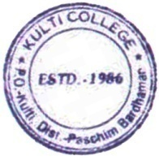

Dr.Supriyo Chakraborty
Principal, Kulti College

